INSURANCE PORTFOLIO ANALYTICS REPORT
Enterprise Insurance Performance & Risk Assessment
1. EXECUTIVE SUMMARY
This report evaluates the performance, risk exposure, and operational efficiency of a corporate insurance portfolio using a modern data warehouse architecture.
The analysis integrates policy, claims, and employee-level data to provide end-to-end visibility into profitability drivers, risk concentrations, and operational bottlenecks.
Key Stakeholder Questions Answered
- Is the insurance portfolio profitable?
- Which policy types are driving losses?
- Where is risk concentrated (coverage, employees)?
- How efficient is claims processing?
- Which insurers and products perform best?
2. PORTFOLIO OVERVIEW
2.1 Key KPIs
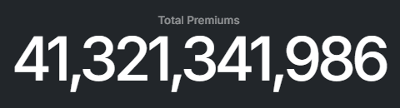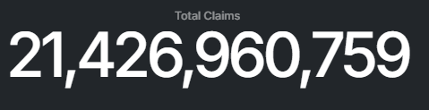
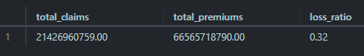
2.2 Policy Distribution
- Portfolio is diversified across multiple insurance products
- However, volume ≠ profitability. High-volume policies may still be loss-making

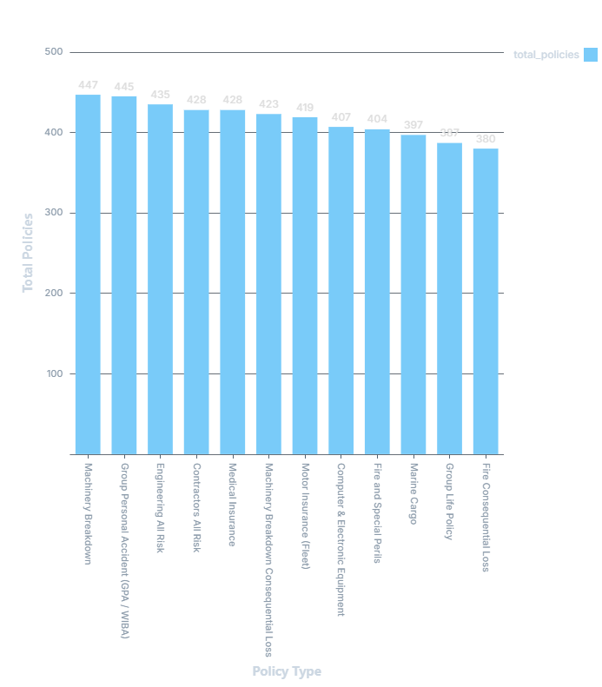

2.3 Coverage Distribution
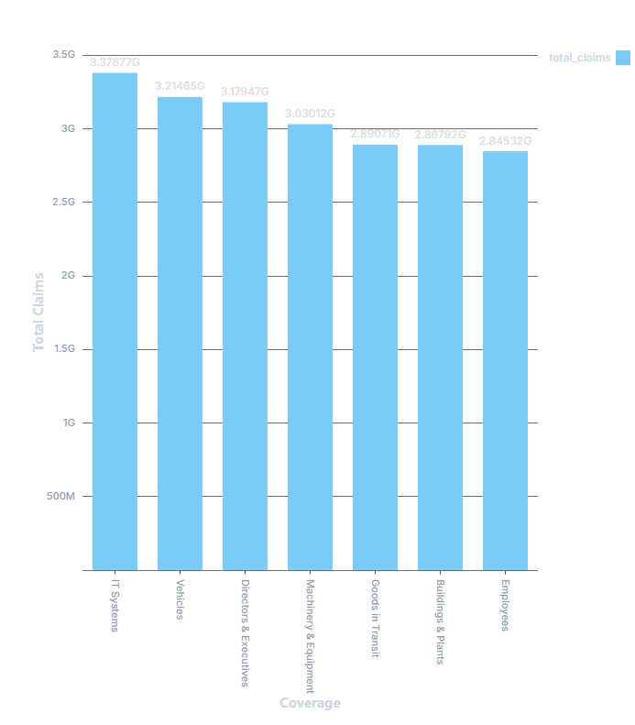
- Coverage types tied to physical assets (machinery, buildings) tend to carry higher financial exposure
- Employee-based policies typically have high frequency but lower severity
3. FINANCIAL PERFORMANCE ANALYSIS
3.1 Premiums vs Claims
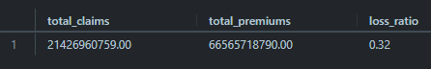
- The gap between premiums and claims determines sustainability
- Narrow gaps signal pricing or underwriting issues
3.2 Policy Profitability
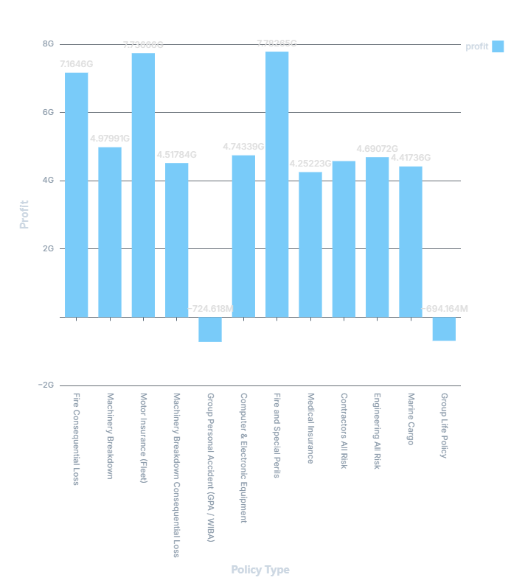
- Profitability varies significantly across products
- Some policies:
  - Generate strong premiums but low claims - high-value
  - Generate high claims - portfolio drag
3.3 Loss Ratio Analysis
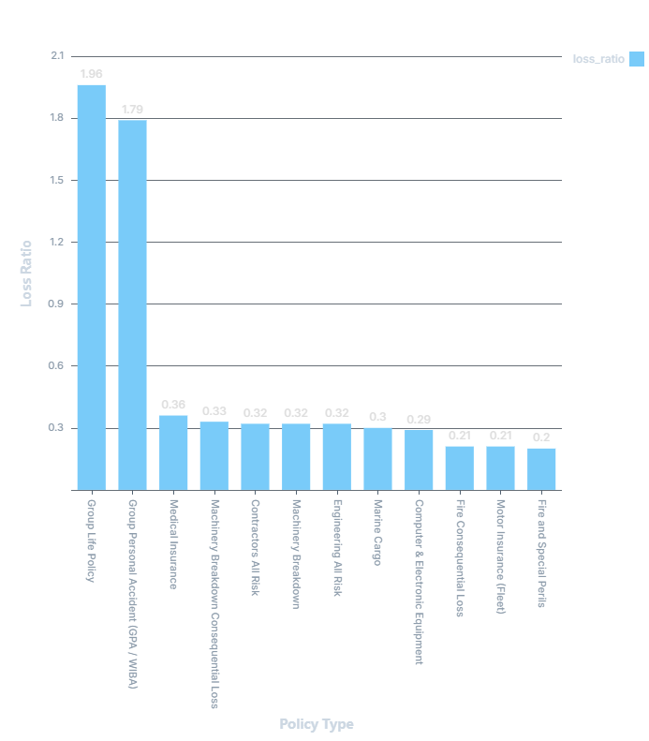
- > 1.0 - Loss-making
- 0.7 - 1.0 - High risk
- < 0.7 - Healthy
Certain policy types consistently exceed acceptable thresholds - pricing misalignment or high-risk exposure.
4. CLAIMS & RISK ANALYSIS
4.1 Claim Frequency

- High frequency = operational risk or weak controls
- Low frequency but high severity = catastrophic risk exposure
4.2 Claims Trend Over Time
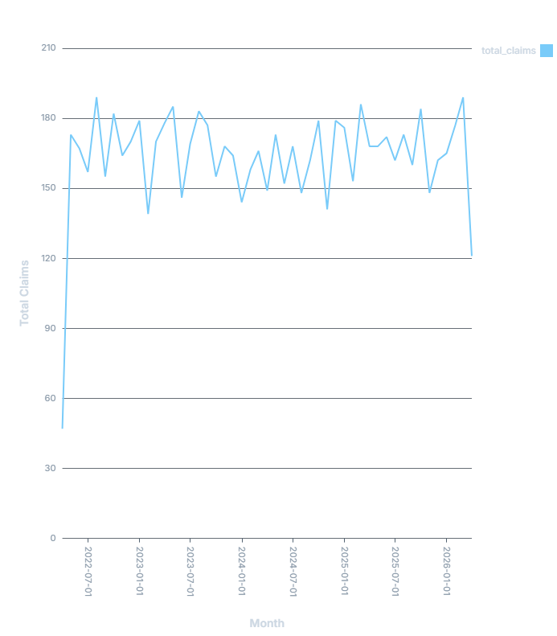
- Presence of seasonality patterns and claim spikes
- Indicates potential operational or environmental risks

4.3 Risk Exposure by Coverage
- A small number of coverage types typically drive majority of claims (Pareto effect)
- Critical for risk mitigation strategy
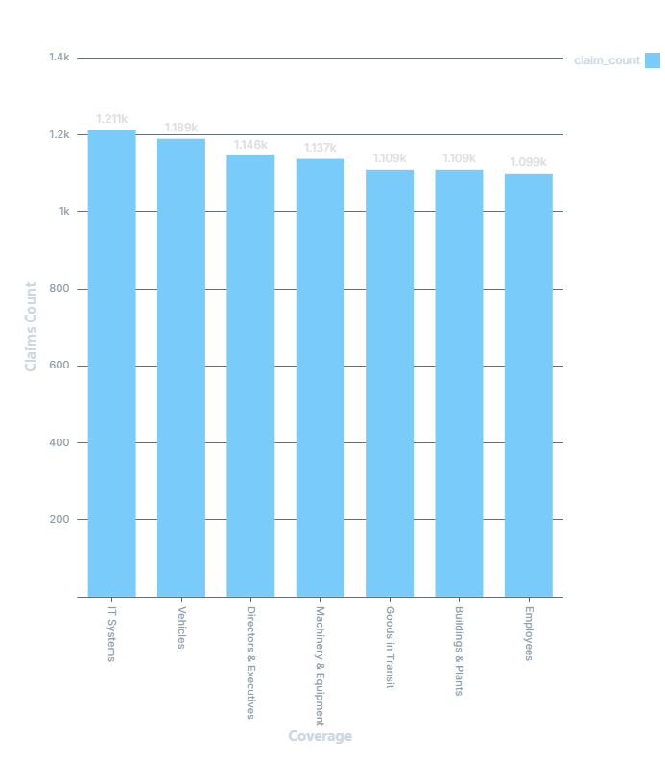

  - Claim Status Analysis
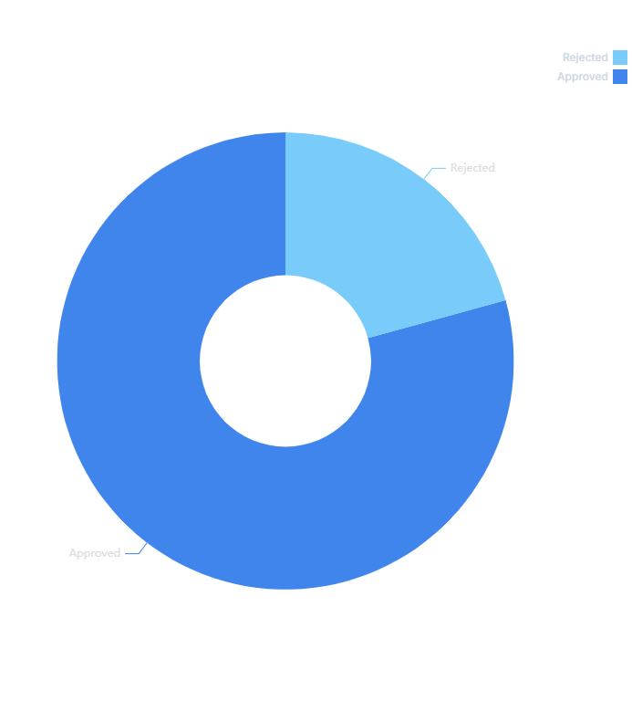
- High rejection rates may indicate strong fraud detection or poor underwriting / unclear policy terms
5. OPERATIONAL EFFICIENCY
5.1 Settlement by Policy Type
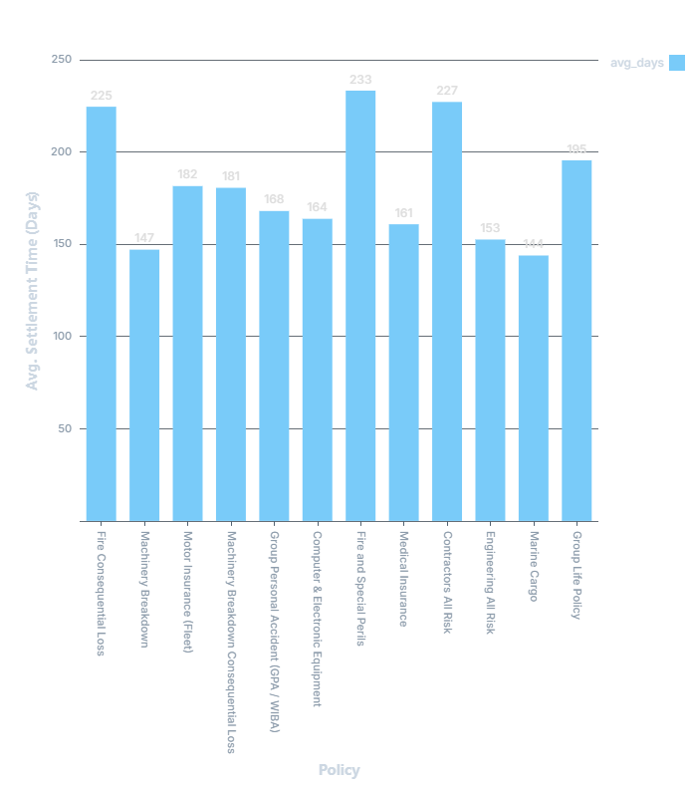
- Complex policies (engineering, fire) take longer
- Simpler policies should be optimized for automation

6. EMPLOYEE & ORGANIZATIONAL RISK
6.1 Employee Risk
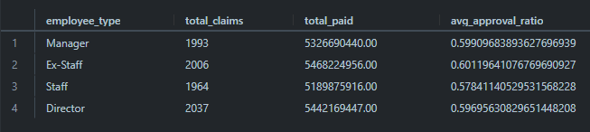
- Different employee groups show different risk behavior:
  - Staff - high volume
  - Executives - lower frequency, higher severity
7. INSURER PERFORMANCE
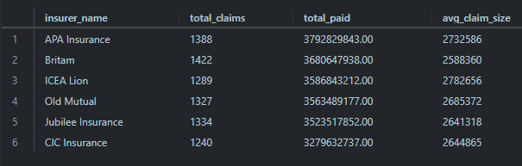
- Some insurers pay faster, handle higher volumes and or manage claim sizes differently.
- Useful for renewal negotiations & vendor strategy
8. KEY INSIGHTS
Financial
- Profitability is uneven - driven by specific policy types
- Loss ratio highlights underpriced or high-risk segments
Risk
- Risk is concentrated in asset-heavy coverage (machinery, buildings) and specific policy categories
Operational
- Settlement times vary widely - inefficiencies
- Claims process is not standardized across policy types
Organizational
- Risk is linked to employee category and department
- Not all groups contribute equally to claims

9. STRATEGIC RECOMMENDATIONS
9.1 Pricing & Underwriting
- Reprice high loss-ratio policies
- Tighten underwriting for engineering and Fire-related coverage
- Introduce risk-based pricing models
9.2 Risk Management
- Reduce exposure to high-loss coverage categories
- Introduce preventive maintenance programs (for machinery risk)
- Strengthen internal controls for high-frequency claims
9.3 Operational Efficiency
- Automate low-complexity claims (motor, employee claims)
- Set SLA targets for claim settlement
- Introduce workflow tracking for bottlenecks
9.4 Portfolio Optimization
- Scale profitable policy types
- Reduce reliance on high-risk segments
- Diversify coverage strategically
9.5 Insurer Strategy
- Benchmark insurers on:
  - Claim payout efficiency
  - Settlement time
  - Claim severity handling
- Use insights for contract renegotiation

